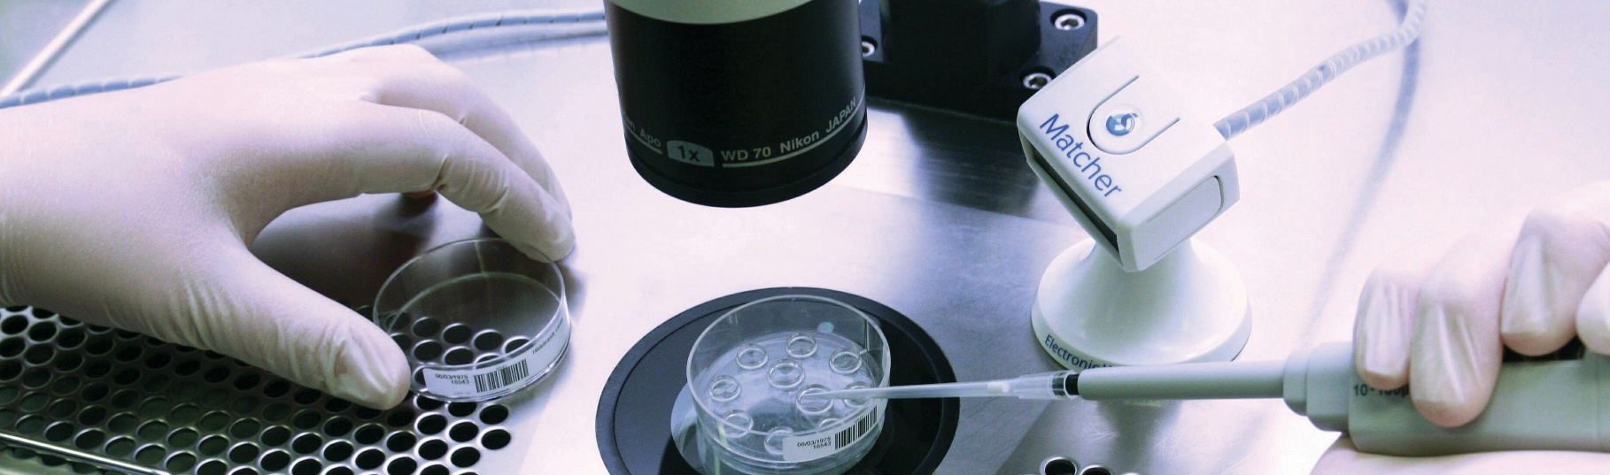


IMT Matcher electronic witnessing & barcode labelling system
Introducing our state-of-the-art Quality Management System

Introduction

We go to great lengths to make sure that everything involved with your treatment is securely and accurately identified and
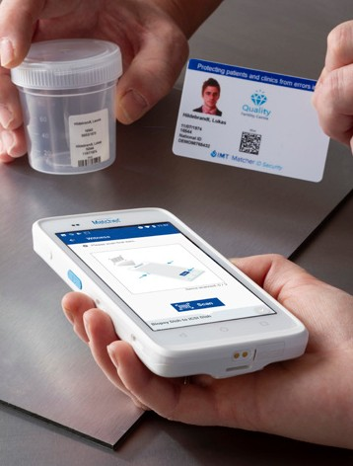
recorded. This involves labelling everything used throughout the course of your treatment (e.g. petri dishes, test tubes) with your full names, dates of birth and your unique ID number. To help achieve this we use the Matcher® electronic witnessing and barcode labelling system.

What is Matcher?
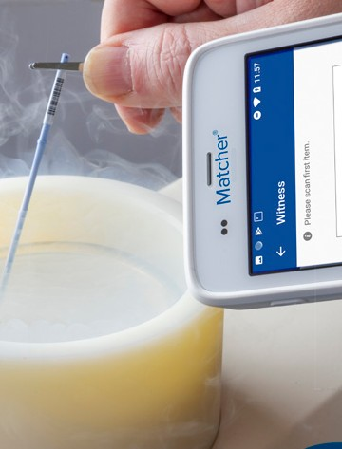
Matcher® is a proven electronic witnessing system used by IVF clinics worldwide. It combines sophisticated equipment, software, barcode labelling and imaging technology to record and double-check the identity of all materials used in every procedure throughout your treatment, with photographic proof. This includes witnessing:
➔ Your identity during egg collection or embryo transfer
➔ The labelling of your semen container
➔ The mixing of sperm and eggs
➔ The movement of embryos between culture dishes
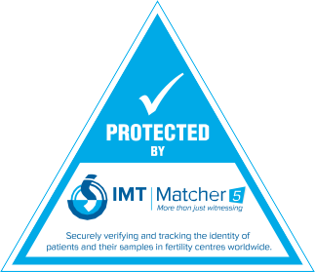
➔ The labelling of straws used to freeze and store gametes and embryos, and all other procedures that occur throughout the clinic.

Will you notice any difference to your treatment?
At the start of your treatment you will be issued with a photo ID security pass – either a card or electronic pass. The photographs and barcode on this pass will be used to confirm your identity when you attend the clinic.

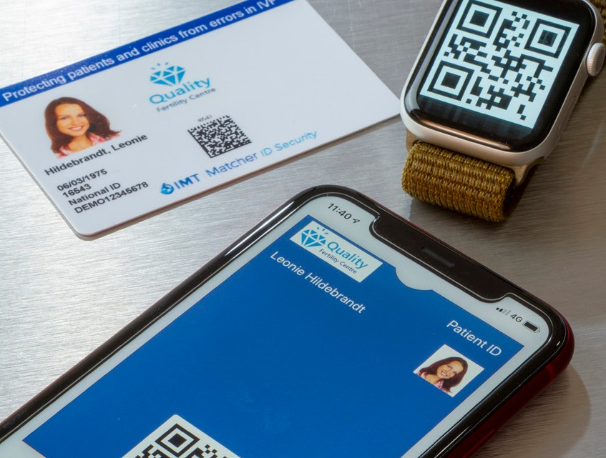

It will also be used to match the identification of sperm or embryos at the point when they are transferred back to you, using a handheld barcode scanner. In addition, all of your cryopreserved sperm, eggs and embryos will be safely recorded and tracked with Matcher®.
How is Matcher® used in the laboratory? Whilst you will not be able to see the procedures that take place within the laboratory, you can still be confident that every procedure carried out will be witnessed, photographed and kept in your records.
What happens if you forget your ID? Don’t worry, we can provide a replacement very quickly from your medical records or at the click of a button in Matcher®.

Are there any risks?
No, Matcher® is a passive system which means that it will not interfere with your treatment cycle. On the contrary, it is designed to help reduce any risks.

More information?
If you would like more information about Matcher®, please do not hesitate to ask a member of the team or visit www.imtinternational.com

2020.11 EN info@imtinternational.com www.imtinternational.com T: +44 (0)1829 771 327

