
[xx IVF centre] equipped with leading edge technology – Matcher5 electronic witnessing system
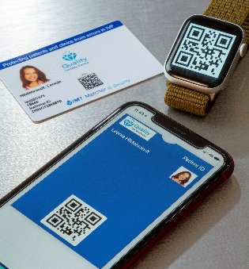
At [xx] we invest in leading edge technological innovations throughout our clinic to help patients achieve the best possible outcomes throughout their treatment with us. We have recently installed the latest version of the Matcher system – a state-of-the-art system designed to ensure that patients and their gametes and embryos are correctly identified, tracked and traced throughout the whole of their cycle of treatment.
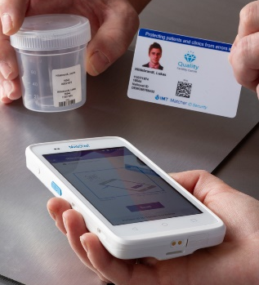
At the start of treatment every patient is issued with a Matcher photo ID security pass or card. The photographs and barcode on this pass are used to confirm their identity when they attend the clinic.
The Matcher system uses barcode technology not only on the ID pass, but also on all lab and cryo labels. This ensures that all pieces of labware used within a patient’s cycle of treatment - including cryo-preserved items - are labelled with a unique barcode as well as readable patient information, ensuring there is no room for human error in reading or writing patient identification.
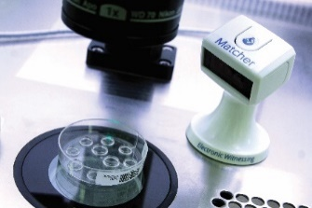
Once the items are labelled, the embryologists use the Matcher camera readers to scan the barcodes on the labware before the gametes or embryos are moved from one dish to another, confirming and recording that the items and labware are correctly labelled and identified.
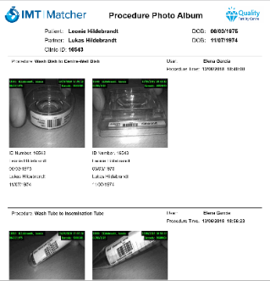
The Matcher system captures time stamped photographs of the barcoded labware being witnessed, ensuring there can be no question about the identity of the items. These photographs can even be printed as a report and given to patients for further peace of mind, knowing that after their precious material goes through the lab doors, they can now see a photo of each dish transfer with confirmation of their identity.
At [xx] we also use Matcher to track all products coming into contact with gametes and embryos and, in case of a product recall, that information can be simply reported out and patients notified where necessary.
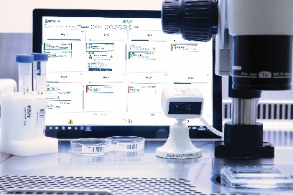
Matcher also provides an electronic version of our cryo-stores within the application, and every time an item is moved in or out of cryo-stores, the inventory and location is updated for every patient, so we have a secure and reliable system for recording whose frozen material is stored in which location.
Using the Matcher system helps us work with confidence knowing that our patients and their gametes and embryos are protected, that the technology is safe, and we are working to industry leading working practices.
For more information about the Matcher system talk to one of the team or visit www.imtinternational.com

