Matcher Electronic Witnessing

Rationale and Standard Operating Procedures

Date: November 2019
Prepared by: [name of clinic]

Contents
1 Executive Summary 3
2 Project Definition 3
2.1 Background Information 3
2.1.1 Regulatory requirements 4
2.2 Business Objective 4
2.3 Benefits and Limitations 4
2.4 Identification and Selection 4
2.5 Product Trial Review 5
2.6 About IMT International 5
2.7 Due Diligence 6
3 Scope, Impact, and Interdependencies 6
3.1 Single clinic or group implementation 6
3.1.1 Standardisation 6
3.2 Impact 6
3.2.1 Equipment 6
3.2.2 Have we had to make changes to the way we work? 7
3.2.3 Is Matcher configured to our existing Standard Operating Procedures? 7
3.2.4 Can Matcher be linked to our existing clinic management system? 7
3.3 Training 7
3.4 Service and support 7
3.5 Interdependencies 7
3.6 Outline Installation Schedule 8
3.7 Risk Factors 8
3.7.1 Is the technology safe? 8
3.7.2 Are the labels safe? 8
3.7.3 Will our confidential patient information be secure? 8
3.7.4 Is Matcher compatible with our quality management system? 8
3.7.5 Validation 9
4 Project Approach 10
4.1 Purchasing Strategy 10
4.2 Pricing 10
5 Standard Operating Procedures 11
5.1 Patient Registration 11
5.2 Printing and issuing ID Cards 13
5.3 Labelling 15
5.4 Witnessing 19
5.5 Workflow Scheduling 22
5.6 Lot Tracking 23
5.7 Cryo Management 26
5.8 Reporting 29
6 Appendix 1: Matcher system hardware examples 31
7 Appendix 2: Witnessing Risk Table – Manual / Matcher / RFID 32
8 Appendix 3: Independent Group Laboratory Director Analysis of Matcher 34
9 Appendix 4: Indicative Time and Cost Analysis 35
10 Appendix 5: Patient Journey Highlighting Areas of Witnessing 36
11 Appendix 6: Summary of Process Maps containing specific Witness Steps 37

Executive Summary

[name of clinic] recognises the risk of error in IVF and under our programme of continual development, steps have been taken to improve our manual witnessing and traceability procedures complimenting our total quality management system (TQM).
Technology is progressing constantly, and we believe that by implementing an electronic witnessing system, we can reduce the risk of mistakes, at the same time as adding the benefits of a comprehensive labelling system, workflow scheduling, batch tracking solution, end-to-end photographic evidence and reporting features. The resulting benefits of this functionality will be to reduce risk, reassure our patients, improve efficiency, increase staff morale, and save time and money.
In addition, anecdotal feedback of the benefits of implementing an electronic witnessing system, have indicated that staff feel more secure and less pressurised with the introduction of an electronic witnessing system, and feel more confident knowing that they can continue their work even if working alone.

Project Definition

Background Information

Despite using verbal checks to ensure patient safety, due to human factors, healthcare staff do make mistakes. One explanation frequently cited for this is that humans are inclined to respond automatically to questioning without matching their actions to their words.

Brian Toft, Professor of patient safety at Coventry University, UK, coined the phrase “involuntary automaticity” to explain the phenomenon following investigation into a series of adverse events relating to misidentification of samples. Toft (2004) concluded that these adverse events were caused through a mixture of inadvertent human error and inadequate double checking.

Introducing automated systems of double-checking such as barcoding was suggested as an effective way of reducing mistakes caused by human error.

Regulatory requirements

Our regulatory requirements for witnessing, labelling and traceability are subject to inspection by [competent authority name and specific regulatory requirements]

It is generally accepted that in most countries around the world IVF is becoming more highly regulated as the industry evolves, increasing the burden of compliance on IVF clinics. Therefore, we are committed to being proactive in meeting the regulatory challenges and using proven technology to do so where possible.

Business Objective

We have a need for a paperless system to address the following challenges:
- Reduce the risk of error within the clinic
- Reduce the staffing time requirements within the clinic
- Improve workflow scheduling
- Improve staff morale and peace of mind
- Improve accuracy and efficiency of record keeping and reporting
- Improve patient satisfaction

Benefits and Limitations

The implementation of an electronic witnessing, labelling, scheduling and traceability system helps the clinic to meet these business challenges in the following ways:
- Risk reduction - an electronic witnessing system should remove the need for a second person to perform double-witnessing, thereby removing the inherent risk associated with involuntary automaticity
- Risk reduction - single label barcoded and eye readable information reduces risk of mis-labelling
- Risk reduction – Matcher provide labels that fit every piece of labware including dishes, tubes, straws and PCR tubes, from all manufacturers
- Risk reduction – Matcher’s photographic proof of every witness step provides a visual chain of custody that can be referenced at any later date in the case of any patient enquiry
- Improve quality - batch / lot tracking enables expired and compromised products to be easily identified and reported and traced to potentially affected gametes/embryos
- Compliance - An automated system helps enforce all team members to follow a common standard set of procedures every time, and record any deviations from the standard route
- Cost savings - there is an associated reduction in staff time required as no second person is required, enabling one person to work alone at weekends / evenings / holidays
- Workflow visibility – the workflow scheduler gives a real-time overview of patient cycle status as well as tasks due, in progress and complete so all staff can see what tasks are complete and who did them, and what tasks are still outstanding for the day
- Staff morale - staff are reassured that there is an automatic system to double check their work and to ensure that all procedures due for that day have been completed
- Reporting efficiencies - Automated inputs and electronic record keeping / witnessing enables one-click reporting across witnessing, working practices, batch / lot tracking, cryo-stores, patient photographic reports
- Improve customer service – patient photo ID cards, individual barcodes and photographic patient reports will improve customer satisfaction and peace of mind that their gametes and embryos will not be mixed up during their treatment cycle.

Identification and Selection

Specifically created for IVF clinics and donor banks, Matcher assists in preventing error through misidentification of patients and their gametes and embryos.

In addition, Matcher provides clinics with electronic traceability, recording “who, what, where and when” at every transfer step. Operating seamlessly throughout the clinic/s, including cryo stores, operating rooms and laboratories, Matcher can be relied on by embryologists, quality managers, nurses and directors alike.

Matcher is the only system that photographs all procedures, throughout the entire treatment cycle. Photographic reports provide visual chain of custody evidence and additional peace of mind for both staff and patients.

The Matcher system comprises a number of modules, providing benefits throughout the clinic.

- Electronic witnessing; A second pair of eyes adding peace of mind to patients and staff
- Process mapping; Forcing function ensures all steps are carried out, in the correct order
- Labelling; Abandon handwriting, with customised clear barcoded labels for every item of labware
- Workflow scheduling: Real-time overview of workflow scheduling gives instant ‘traffic light’ view of daily cycle tasks and patient cycle status
- Batch tracking; Automatic paperless traceability of all labware and media used
- Photo ID card security; Added peace of mind for patients and extra visual check for staff
- Cryo management; Identify, track and locate all material stored in liquid nitrogen
- Reporting; For auditing and compliance, including photographic evidence

Overview of Benefits of the Matcher system:
- Error prevention
  - Helps minimise risks of human error, including misidentification, alerting to mistakes before an incorrect transfer of material takes place
- Replaces all human double-checking
  - No second human confirmation required, allowing staff to work autonomously with reduced disruption and distraction
- Automatic traceability
  - Matches, confirms and photographs the identity of the patient and unique item identifier on all labware in every procedure
- Real-time workflow overview
  - Real-time overview of workflow scheduling gives instant ‘traffic light’ view of daily cycle tasks and patient cycle status
- Compliance
  - Legal/regulatory - assists clinics to comply with competent authority requirements for witnessing, labelling and traceability
  - Validation - full validation support and risk assessment included as part of the implementation and ongoing support
  - Quality management - fits in closely with clinics’ ISO accreditations
- Time Saving
  - Saves staff hours spent on witnessing, traceability and compliance as well as reducing overtime hours and holiday/maternity cover
- Unbroken chain of custody
  - Witnessing takes place at every step of a cycle of treatment, from registration to cryo stores, with no additional human verification required
- Photographic evidence
  - Every procedure is photographed, providing clear visual evidence of patient label details and complete photographic cycle history
- Safe technology
  - Matcher uses digital photo images to read the barcoded labels, without the use of lasers, radio frequency radiation or supplementary heating (no FDA approval required in USA)
- No capital cost
  - Fees are ‘per cycle’ only with no up-front costs and no hidden costs. Fees include equipment, installation, training, service, support, upgrades and consumables
- Flexible positioning
  - The new Matcher5 reader has a very small footprint – ideal for small cabinets and isolettes – and can be positioned in any location, including under the microscope
- Simple installation
  - Quick and easy to install, including all testing and training with no equipment modifications required

Refer to Appendix 3: Independent Group Laboratory Director Analysis of Matcher

Product Trial Review

Following an initial assessment of the electronic witnessing market we decided to opt for implementation of the IMT Matcher system on the basis that it already fitted many of our criteria for a witnessing system. We have conducted a review of the trial, resulting in the following observations:
- Installation
- Training
- Ease of use
- Coverage (Refer to Appendix 6; Processes and Procedures Witnessed by Matcher)
- Error prevention
- Cost / time analysis (Refer to Appendix 4; Matcher Time and Cost Analysis)

About IMT International

IMT International have been providing innovative solutions in ART for customers around the world for many years.

They apply a rigorous approach to quality in all their work and systems, including recognised standards such as ISO 9001 Quality Management Systems, and GAMP (Good Automated Manufacturing Practice) frameworks.

Due Diligence

We have contacted a number of other Matcher customers to obtain feedback from their use of the system, the reasons why they chose it over alternative systems, and their experiences of transitioning from manual witnessing to electronic witnessing with Matcher.

Influential Matcher users include:

- Australia
  - Fertility SA, Adelaide
- Germany
  - CERF (Centrum fur Gynaekologische Endokrinologie und Reproduktionsmedizin Freiburg)
  - Fertility Center Hamburg
  - Kinderwunschzentrum Ulm
- Kuwait
  - Dar al Baraa, Kuwait City
- Luxembourg
  - CH Luxembourg
- Netherlands
  - ISALA Fertiliteitscentrum, Zwolle
- Spain & Portugal
  - IVI Group (all centres)
- Switzerland
  - LUKS Luzerner Kantonsspital, Lucerne
- UK & Ireland
  - Birmingham Women’s Fertility Centre
  - CARE Fertility Group (all centres)
  - Galway Fertility Unit
  - Leeds Centre for Reproductive Medicine
- USA
  - Dominion Fertility, Arlington VA
  - RRC, Kansas
  - Aspire, Atlanta
  - SIU, Illinois

Scope, Impact, and Interdependencies

Single clinic or group implementation

Standardisation
With multiple clinics in a group using Matcher there are advantages from being able to standardise aspects of our workflow and quality control processes. This includes being able to ensure a common set of standard operating procedures for witnessing steps, identifying samples and recording individual lots of consumables. The data captured by Matcher gives us the ability to monitor any discrepancies between staff at different centres, e.g. time taken between key transfer steps, volume of media used over time, and rates of ‘near misses’. This data should help disseminate best practice, identify outliers and measure the impact of changed procedures on error risk.

Standardisation of these aspects of our quality management system should also help when staff move from one clinic to another, and reduce the risk from unfamiliarity with different local standard operating procedures.

Impact

Equipment
IMT International have supplied all the equipment needed to cover all areas where we perform transfers of material and other identity checks. Typically, each of our workstations (e.g. laminar flow cabinets) where we perform witness steps are equipped with a mini Benchtop Matcher reader device connected to a tablet computer. IMT International have also suppied handheld mobile Pocket Matcher devices to cover all other areas e.g. cryo stores, operating theatre, treatment rooms. In addition we have been provided a photo ID card printer, inclusive of blank ID cards and a Labels printer inclusive of blank labels for non-cryo and cryo use.

Have we had to make changes to the way we work?
Apart from saving time by replacing human witnessing and manual data entry, handwriting on dishes and tubes etc, we have not changed anything. Matcher is highly flexible and configurable to our standard operating procedures. As part of the implementation Matcher understand our workflow and adapt the system to fit.

Is Matcher configured to our existing Standard Operating Procedures?
Yes, the system is adapted to our own SOPs and witnessing steps, using our specific terminology and nomenclature. This also extends to Process Mapping, Matcher’s in-built forcing function for ordering all witness steps into our prescribed sequence, and defining our own lists of labware, media and consumables for use in batch tracking (refer to Appendix 6).

Can Matcher be linked to our existing clinic management system?
The Matcher database can be linked with any other database in order to share information. This typically includes at least the patients’ name, date of birth and ID number, and the same details for their partner. This avoids duplication of information, removing risk from transcription errors and saving us time. This can also include information automatically captured by Matcher e.g. batch data, and data on cryo-preserved material. There are several methods to link, including HL7 (Health Level 7), Mirth Connect and ODBC protocols, which their engineers manage with our IT department/database provider.

Training

As part of the implementation and validation of the Matcher system, training was provided for users of the system in accordance with a clinic-defined and agreed training schedule. The training is delivered in a variety of formats and involves remote webinars, online self-learning resources (e-Learning), and on-site in-person training.
All Matcher users are required to complete an e-Learning course of modules relevant to their specific user requirements prior to using Matcher. Courses are provided to individual users and monitored by Matcher Technologies. A certificate of competence is issued following completion of initial training.

Service and support

- No downtime; we need to rely on a system to work every time, without downtime whilst we wait for support
- Responsive; IMT International commit to providing the highest levels of service and responsiveness, whatever time of day or week, provided by their distributors and expert support engineers
- No extra cost; they do not charge us extra for service or software upgrades

Interdependencies

We should bear in mind that the following teams will need to be considered in advance and may need to be involved during planning of the implementation of Matcher.
- Patients; will need to be provided with information about Matcher (can be supplied by IMT International) in the waiting room and before any semen or oocyte collection. We may want to use implementation as a positive marketing opportunity for patient recruitment, and reassurance about quality control procedures
- Lab Director/Lab Manager; will need to work with the IMT Matcher team to set up the witnessing steps and process maps to fit our workflow. Also, to understand what reports will need creating to monitor performance
- Quality Manager; will need to work with the IMT Matcher team to ensure we can rely on tracking consumables and other products in Matcher and safely transition from our current recording system. Will also need to understand what reports will need creating to monitor performance
- Embryologists & Andrologists; we should allocate a product specialist to be the main point of contact within the team for training the rest of the team and coordinating feedback to IMT Matcher. The team will need the most comprehensive training as they will use the system the most
- Nurses; will be involved in witnessing taking blood samples, preparation of patients before gamete collection, embryo transfers and inseminations. Also if we extend batch tracking of consumables to include nursing products
- Administration team; the receptionists will need training to register patients into the Matcher database, print their photo ID cards, and also may print the barcode label sheets
- IT team; will need to be heavily involved in planning to satisfy themselves regarding set-up of the system and providing servers and any other technical requirements, plus security of patient data and access to the IT network by IMT Matcher engineers for installing and supporting the system
- All other staff: should be made aware of Matcher, any potential impacts, and why we are implementing it

Outline Installation Schedule

Risk Factors
Refer to Appendix 2 – Witnessing Risk Table

Is the technology safe?
Matcher is considered totally safe because the system does not expose gametes or embryos to anything potentially harmful - Matcher uses digital photo images to read the barcoded labels, without the use of lasers, radio frequency radiation or supplementary heating (no FDA approval required in USA).
In addition, there is no additional risk of spillage or supplementary heating as the dishes remain flush on our existing work surfaces.

All aspects of the system are tested and can be validated to give us additional peace of mind.

Are the labels safe?
Yes. All labels are mouse embryo assayed and sperm assayed, and much human embryo work has been done that demonstrates the materials, adhesive and printer toner used on labels is safe. Cryo-labels are also validated to test they will not fall off even after long term storage in liquid nitrogen. Cryo-labels are also self-laminating so that information cannot rub off. Matcher labels have been used in IVF clinics since 2005.

Will our confidential patient information be secure?
Absolutely. There are multiple tiers of security in place from internal security policies to login passwords and firewalls to secure the information in the database. In addition, portable Pocket Matcher devices never store information, so if they leave the clinic (e.g. are stolen or accidentally left in a bag) patient information cannot be taken with them.

Is Matcher compatible with our quality management system?
IMT International are an ISO 9001: 2015 accredited company which focuses on quality management systems. The Matcher system becomes part of our clinic’s quality management framework, and they can provide expert advice to assist us reaching the fully validated state including risk assessment for GMP. They strongly believe in and adhere to industry recognised methodologies for validation, project management and software development such as ‘Agile’ and ‘GAMP4’.

Validation

As part of the implementation, of IMT International’s expert staff have assisted us in the process of validation of the system, offering their experience and advice to help us through this critical activity.

IMT International recommend adhering to an industry recognised framework for Good Automated Manufacturing Practice (GAMP). GAMP is both a technical subcommittee of the International Society for Pharmaceutical Engineering (ISPE) and a set of guidelines for manufacturers and users of automated systems in the pharmaceutical industry. More specifically, the ISPE's guide The Good Automated Manufacturing Practice (GAMP) Guide for Validation of Automated Systems in Pharmaceutical Manufacture describes a set of principles and procedures that help ensure that products have the required quality.

The IMT Matcher team have experience with assisting clinics to reach and maintain the validated state for the Matcher system, covering many countries each operating within widely differing regulatory environments.

Project Approach

Purchasing Strategy

We concluded the best purchasing approach is to amortise the risk of the project cost by paying on a per patient cycle approach, as opposed to seeking a solution with up-front investment costs. We believe this will give us the following advantages:
    - We will only pay for what we use
    - There will be no capital outlay risk
    - Could be funded out of our operating budget instead of needing to request additional funding

Pricing

The IMT Matcher system pricing structure is as follows
- No capital cost; the standard pricing approach includes no capital cost at all
- On-going service; Matcher is provided as a service
- Fee per cycle; the only charge is a small fee per patient treatment cycle
- All inclusive; the cycle fees are all-inclusive, with no hidden extras, covering:
    - All equipment;
    - Installation;
    - Configuration to the clinic’s SOPs;
    - Validation support;
    - Training of users;
    - Consumables, e.g. ID cards, labels;
    - Service and support; and
    - Software upgrades as released.

The results of the trial time/cost analysis are available in Appendix 4

Standard Operating Procedures

Patient Registration

What: Patient Registration in Matcher
Last reviewed: [date of review]
Reviewed by: [name of reviewer]
Who: Reception and Laboratory staff (embryology and andrology)
Where: Reception PC
When: To coincide with the first patient visit, or in advance of the first cycle of treatment.
Scope and purpose: To enter the patient details into the Matcher database (Clinic identifier, Name, date of birth, and National ID number) for the purpose of ID card security, labelling, and electronic witnessing.
Where possible, patient details should be imported from the clinic electronic management record system (EMR) to avoid duplication of information and transcription error.
Equipment and supplies: Reception PC, Matcher application, integration with clinic EMR
Supporting training material: Matcher support portal, Matcher User guide section 5, Matcher e-Learning module number 2

Standard Procedure: Patient registration
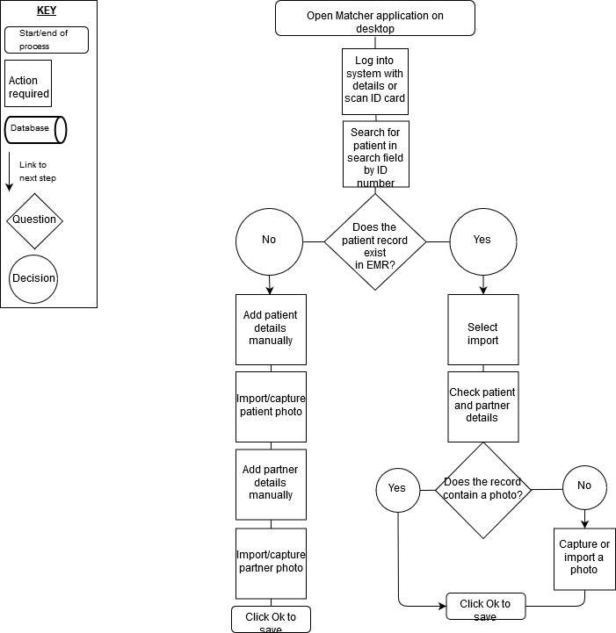

Printing and issuing ID Cards

What: Printing and issuing ID cards in Matcher
Last reviewed: [date of review]
Reviewed by: [name of reviewer]
Who: Reception and Laboratory staff (embryology and andrology)
Where: Reception PC
When: To coincide with the first patient visit, or in advance of the first cycle of treatment.
Scope and purpose: To create and issue an ID card to a patient and their partner at the time of registration into Matcher for the purpose of issuing a primary patient identifier, including a unique barcode. The ID card is intended to be used to identify the patient at the point of check-in, blood drawing, oocyte collection, sperm collection, embryo transfer and also to check patient identity against medical records
Equipment and supplies: Reception PC, Matcher application, ID card printer, plastic ID cards, dye film for printer
Supporting training material: Matcher support portal, Matcher User guide sections 5 and 8, Matcher e-Learning module number 4

Standard Procedure: Printing and issuing ID cards
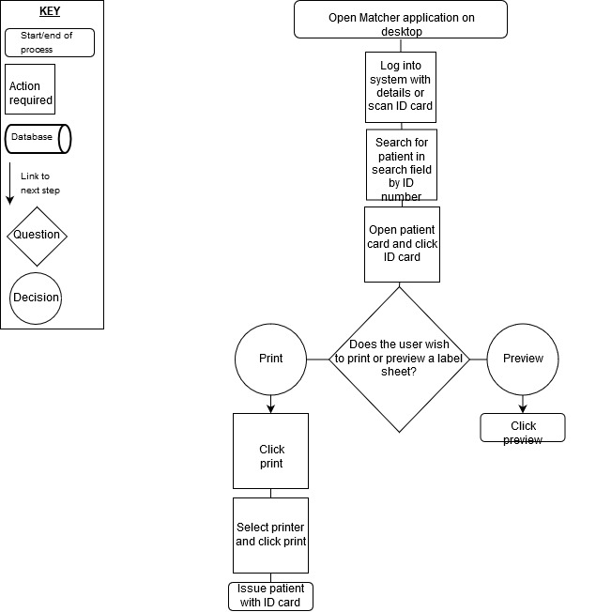

Labelling

What: Labelling in Matcher (not for cryo-use)
Last reviewed: [date of review]
Reviewed by: [name of reviewer]
Who: Laboratory (embryology and andrology) and nursing staff
Where: Laboratory and nurses’ station PC
When: The day before a patient cycle (day -1)
Scope and purpose: To create a non-cryo label sheet providing eye readable (3 identifiers) and machine readable (barcode) labels for all dishes, tubes, sperm containers, medical records and devices used throughout the forthcoming cycle of treatment. All patient identifiable items are labelled in advance of the introduction of biological material (tissue and cells including gametes, embryos and blood). Dishes and tubes used for media equilibration are labelled prior to incubation.
Eye readable identifiers must include patient name, date of birth and patient ID number.
Every individual label is uniquely identifiable by the barcode.
Equipment and supplies: Laboratory PC, Nurse station PC, Matcher application, Matcher validated label printer, printer toner, blank non-cryo Matcher label sheets, folder for holding printed label sheets.
Supporting training material: Matcher support portal, Matcher User guide sections 9 and 17, Matcher e-Learning module number 4

Standard Procedure: Labelling for non-cryo use
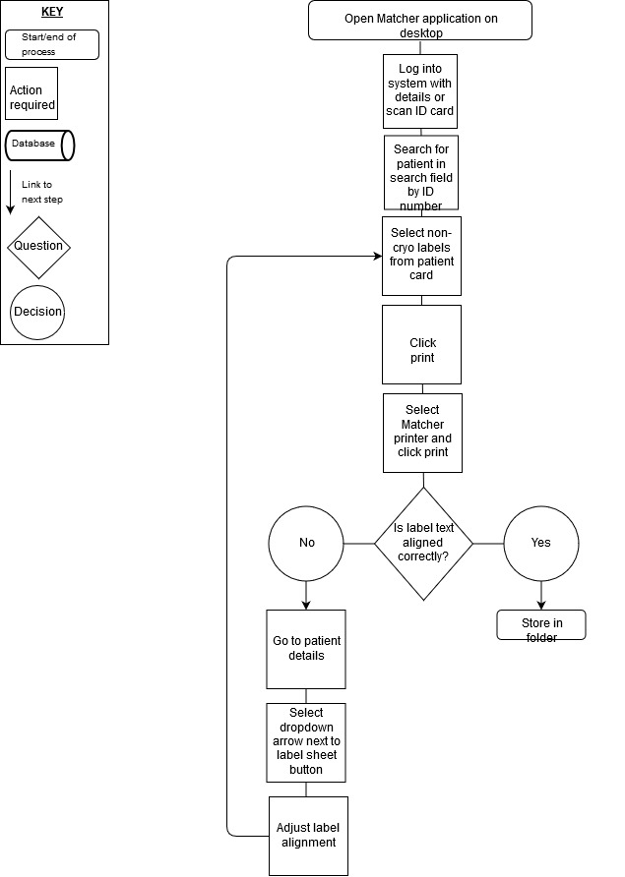
What: Labelling in Matcher (for cryo-use)
Last reviewed: [date of review]
Reviewed by: [name of reviewer]
Who: Laboratory staff (embryology and andrology)
Where: Laboratory and nurses’ station
When: On the day of processing a new batch of oocytes, sperm, embryos and testicular biopsy for cryopreservation or vitrification. Labels are created after the estimated quantities are known and before cryopreservation or vitrification occurs.
Scope and purpose: To create a cyolabel sheet providing eye readable (3 identifiers) and machine readable (barcode) labels for all straws, vials and vitrification devices containing oocytes, sperm, embryos and testicular biopsy.
Eye readable identifiers must include patient name, date of birth and patient ID number.
Every sample must be uniquely numbered and the date of freeze, quantity of oocytes/embryos contained in the device, stage of embryo development and the licence number of the clinic must be clearly marked.
Every individual label is uniquely identifiable by the barcode.
Equipment and supplies: Laboratory PC, Matcher application, Matcher validated label printer, printer toner, blank ‘for cryo use’ Matcher label sheets, folder for holding printed label sheets
Supporting training material: Matcher support portal, Matcher User guide sections 9 and 17, Matcher e-Learning module number 4

Standard Procedure: Labelling for cryo-use
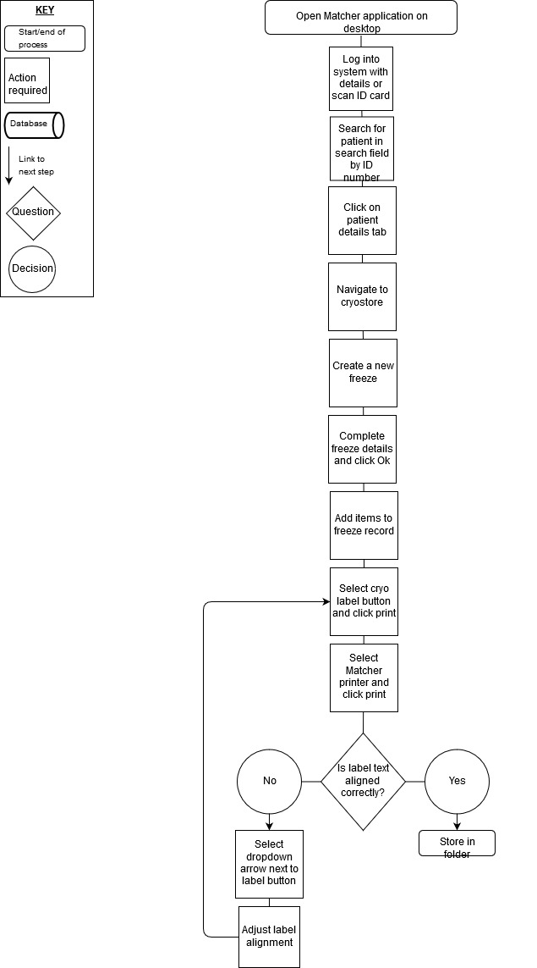

Witnessing

What: Witnessing in Matcher
Last reviewed: [date of review]
Reviewed by: [name of reviewer]
Who: Laboratory (embryology and andrology), nursing staff, clinical staff and Quality Manager.
Where: Point of sperm collection, Operating Rooms, sperm preparation laboratory, IVF laboratory, cryo laboratory, cryo stores and blood-drawing room (phlebotomy).
When: At every stage through every patient cycle where biological material is transferred from one receptacle to another or where a confirmation of patient identity is required in accordance with the clinic’s pre-configured Matcher process maps
Scope and purpose: To double check (by electronic witnessing), confirm, photograph and record patient identity at every stage of every patient cycle where biological material transferred from one receptacle to another or where a confirmation of patient identity is required. Witness steps are in accordance with this clinic’s pre-configured Matcher process maps. Please refer to a summary of all pre-configured Matcher process maps in Appendix 6.
Electronic witnessing is used for the purpose of trapping, preventing and mitigating error caused by misidentification at every stage of the patient cycle.
The scope and purpose are also to provide an electronic chain of custody for each patient including photographs of every event through Matcher’s reporting system.
Practitioners will be alerted prior to the incorrect transfer of material by a clear, audio-visual alert and unresolved ‘no-matches’ will be clearly displayed to all users.
Equipment and supplies: Tablet PC, Matcher application connected to mini Matcher imaging device at every fixed position workstation (e.g. laminar flow cabinets), Wifi access point(s), wireless Pocket Matcher imaging device available in all other locations. Please refer workflow diagram to in Appendix 5.
Supporting training material: Matcher support portal, Matcher User guide sections 10 – 13, Matcher e-Learning module numbers 8 and 9

Standard Procedure: Witnessing with benchtop
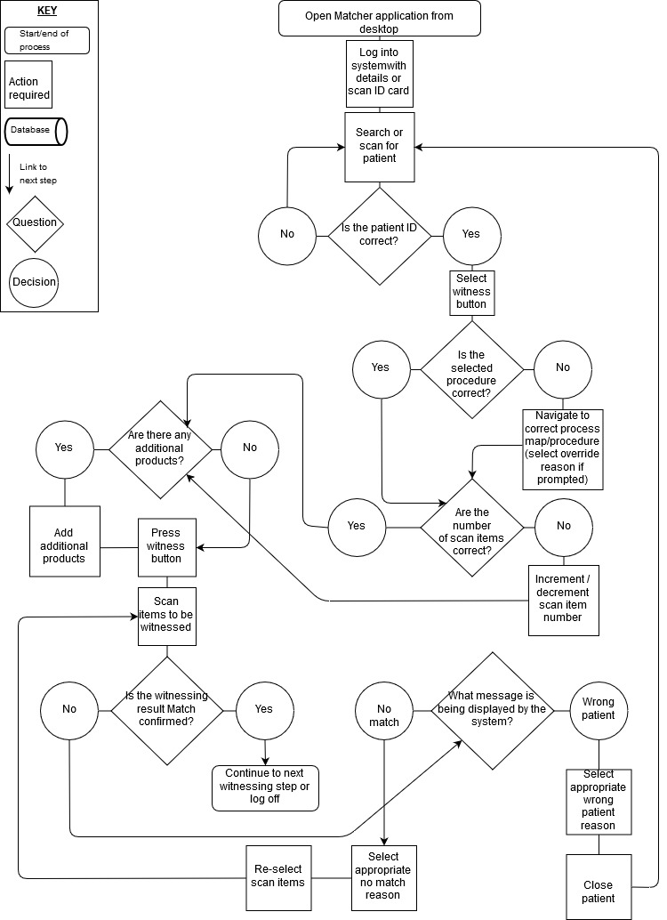

Standard Procedure: Witnessing with Pocket Matcher
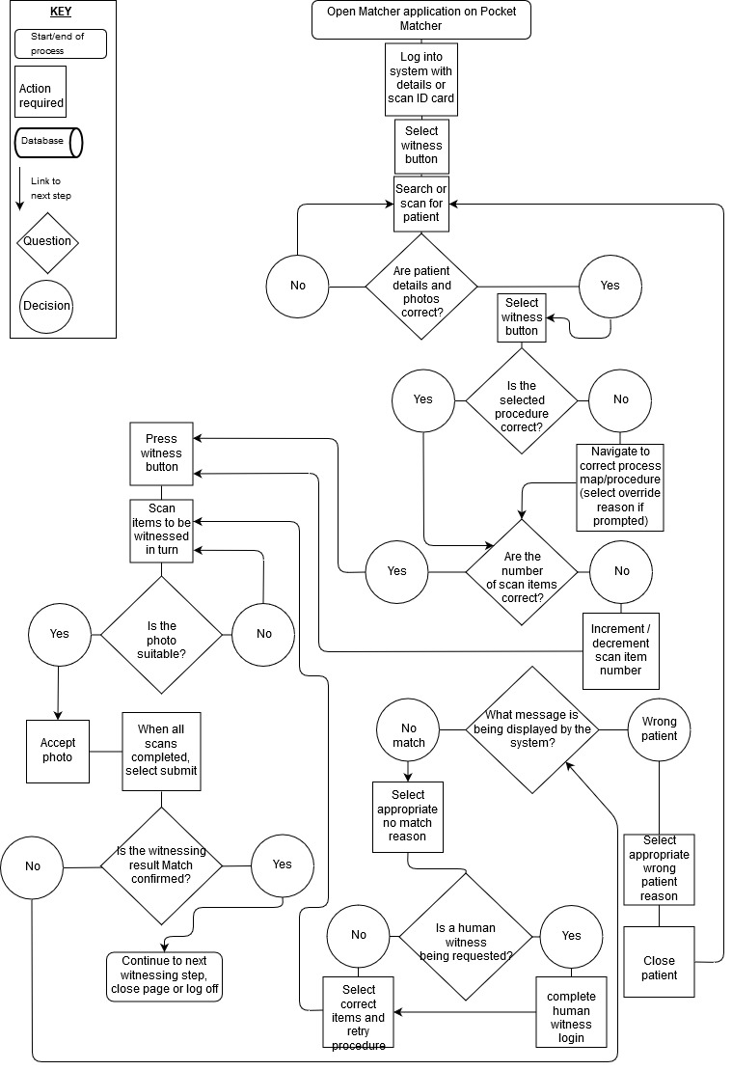

Workflow Scheduling

What: Workflow Scheduling in Matcher
Last reviewed: [date of review]
Reviewed by: [name of reviewer]
Who: Laboratory (embryology and andrology), nursing staff, clinical staff and Quality Manager.
Where: Every PC or tablet where the Matcher application has been installed.
When: To be reviewed at the beginning of each procedure and regularly throughout each working day.
Scope and purpose: To be able to observe and review, at a glance, all patients actively receiving treatment. Information pertinent to their cycle must also be clearly visible, including the patient cycle day, type of cycle, last procedure performed and next expected procedure(s).
Notifications in the form of a traffic light system must be clearly visible denoting activity not yet started (white), in progress (amber), completed (green) and overdue (red).
Equipment and supplies: Matcher tablets and PCs throughout clinic, Matcher application.
Supporting training material: Matcher support portal, Matcher e-Learning module number 7
Standard Procedure:
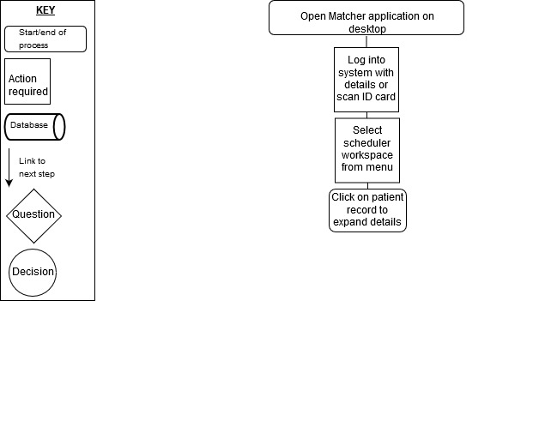

Lot Tracking

What: Lot Tracking in Matcher
Last reviewed: Dr Jefferey Wang
Reviewed by: 15th November 2019
Who: Quality Manager, Stock Manager, Laboratory Staff (embryology and andrology) and nursing staff
Where: Store room, Laboratories and Nurses station.
When: At the point of opening and starting new consumable products.
Scope and purpose: To record the opening and starting of new lots of consumable products coming into contact with patients and their gametes and embryos. The active lot numbers are associated with patients and procedures at the point of witnessing.
Expiry dates and use within dates must be continuously monitored through the Matcher lot alert system and caution must be applied to the use of expired products
In the event of a product recall, lots of products should be easily identifiable including events where exposure to patients and their gametes and/or embryos has occurred.
The clinic must be able to demonstrate traceability of lots opened and started and lots coming into contact with patients and their gametes and embryos through the reporting and alerts functionality within Matcher
Equipment and supplies: multiple PC with Matcher application installed pre-configured with all products used and association with witness steps, Pocket Matcher devices for scanning existing lot numbers or GS1 identifiers on products.
Supporting training material: Matcher support portal, Matcher User guide sections 14 and 15, Matcher e-Learning module numbers 13 and 14

Standard Procedure: Lot tracking on PC
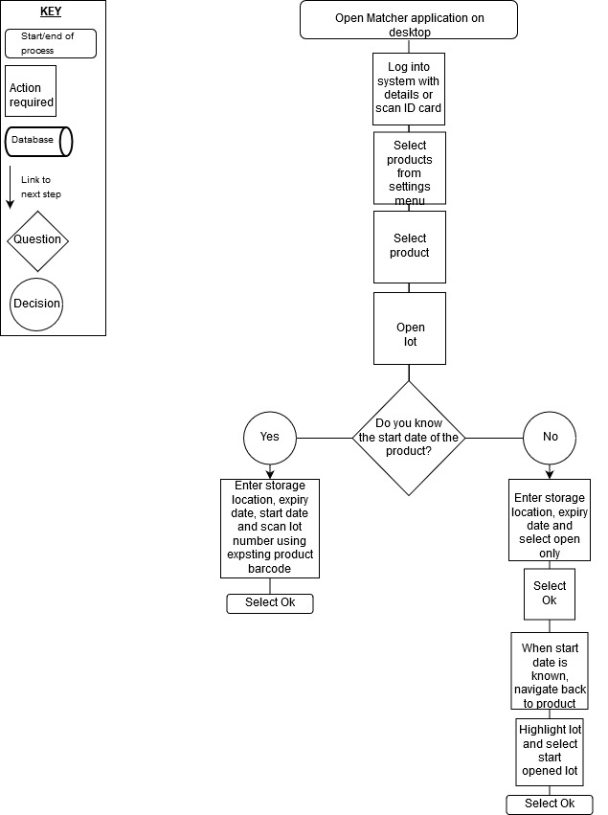

Standard Procedure: Lot tracking on Pocket Matcher
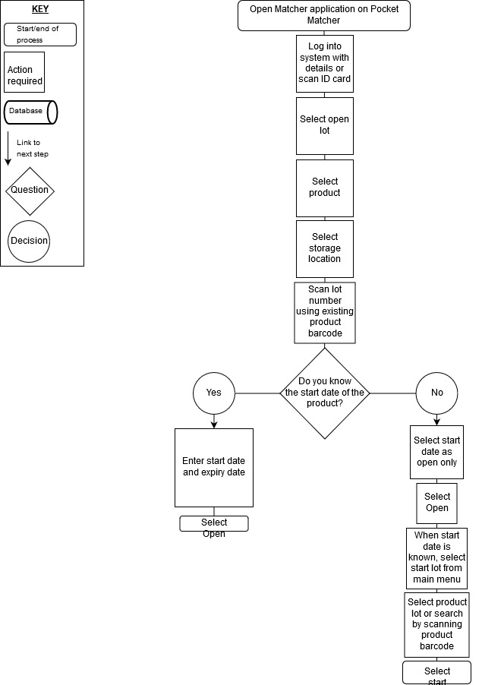

Cryo Management

What: Cryo Management in Matcher
Last reviewed: [date of review]
Reviewed by: [name of reviewer]
Who: Cryo-stores manager, Quality Manager, Laboratory staff (embryology and andrology)
Where: Cryo-stores and Laboratory
When: At the point of allocating items to the cryostore(s) and at the point of removing items for use, disposal or relocation. Also, for general inventory management and at the point of scheduled auditing of cryo-stores.
Scope and purpose: To allocate cryopreserved or vitrified samples of oocytes, sperm, embryos and testicular biopsy to available and suitable locations within the pre-configured cryostores in Matcher.
To accurately locate cryopreserved or vitrified samples of oocytes, sperm, embryos and testicular biopsy within cryostores.
To demonstrate an adequate system for traceability of cryopreserbded or vitrified samples including audit reports, patient reports, vessel report and stock movement reports.
Equipment and supplies:
Supporting training material: Matcher support portal, Matcher User guide sections 17 and 36 -40, Matcher e-Learning module number 4,11 and 23

Standard Procedure: Allocating items to cryo stores
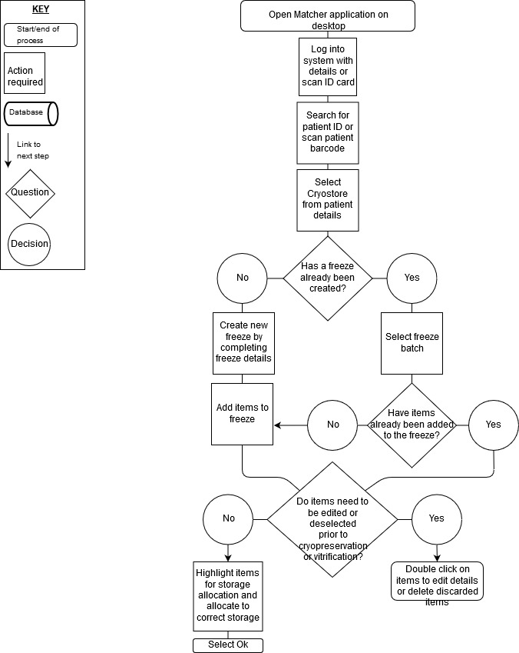
Standard Procedure: Removing or moving items in cryo stores

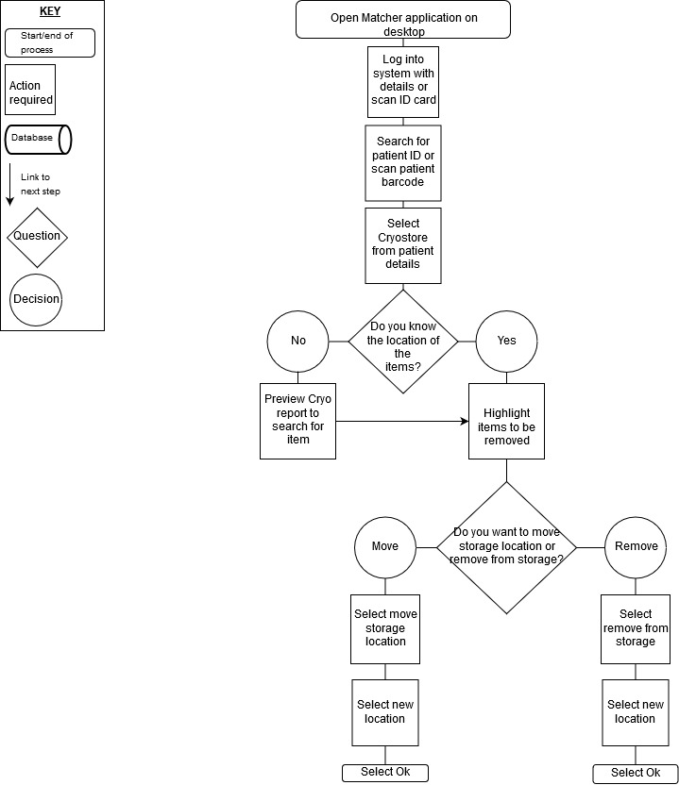

Reporting

What: Reporting in Matcher
Last reviewed: [date of review]
Reviewed by: Dr Jefferey Wang
Who: Clinic Director, Quality Manager, Stock Manager, Laboratory Staff (embryology and andrology) and Cryostores Manager
Where: Clinic Director PC, Quality Manager PC, Stock Manager PC, Laboratory Staff PCs and tablets (embryology and andrology) and Cryostores Manager PC
When: At the point of Auditing
Scope and purpose: To be able to quickly and conveniently access a variety of reports covering all aspects of Process flow, witnessing, lot traceability, cryostores management and cycle management.
To schedule regular reports to periodically review procedures witnessed, mismatches, procedural non-conformities, active products, lot traceability, biological timings and other key performance indicators (KPIs)
To have a system to compliment the clinic’s electronic medical records (EMRs) and total quality management system (TQM) for root cause analysis, reacting efficiently to non-conformities or adverse events, evidence based chain of custody for supporting best practice, ensuring witness steps are carried out in the correct sequence and not missed out and adherence to standard operating procedures (SOPs).
Equipment and supplies: Clinic Director PC, Quality Manager PC, Stock Manager PC, Laboratory Staff PCs and tablets (embryology and andrology) and Cryostores Manager PC, Matcher application, export functionality (PDF, excel).
Supporting training material: Matcher support portal, Matcher User guide sections 16, Matcher e-Learning module number 18 and 24

Standard Procedure: Reporting
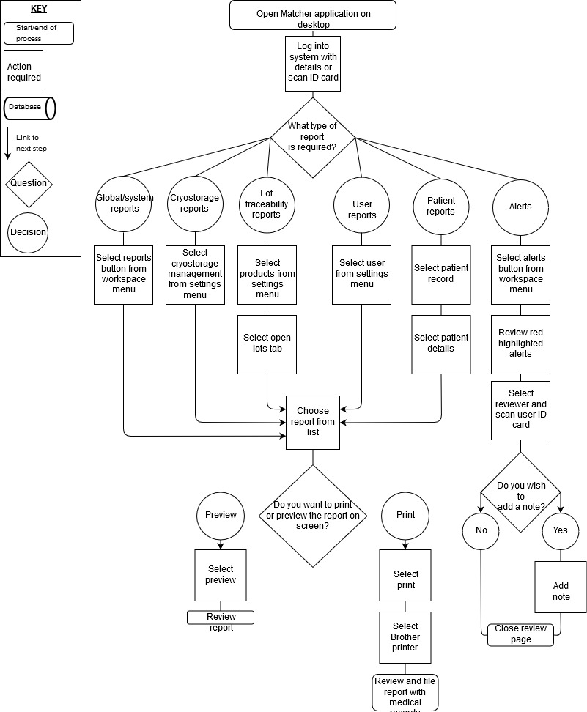

Appendix 1: Matcher system hardware examples

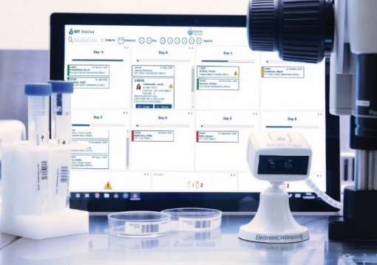
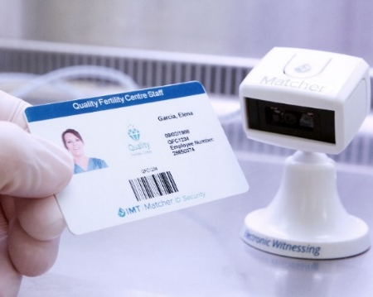

Tablet and software
USB Mini Benchtop Matcher device

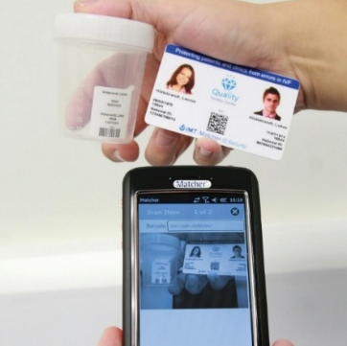

ID card and label sheets
(cryo and non-cryo)
Pocket Matcher wifi portable device

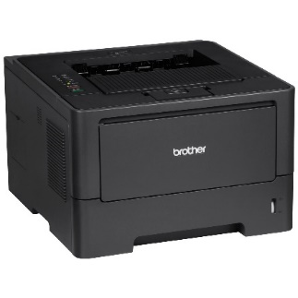
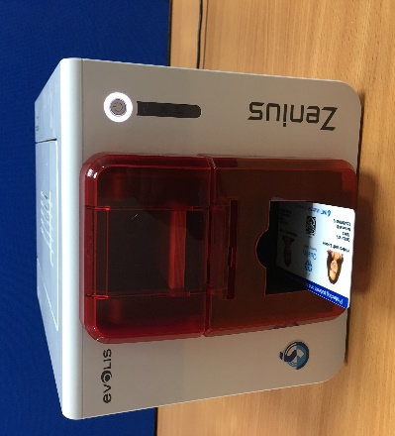

Label sheet printer

Label sheet printer
ID Card printer

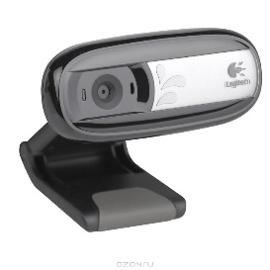

Webcam

Appendix 2: Witnessing Risk Table – Manual / Matcher / RFID

Hazard | Applicable to: |  |  | Comments for Matcher
 | Manual witnessing | RFID | Matcher
Users
Involuntary automaticity | Yes | No | No | Removes human verification
Distractions from requesting and waiting for a witness | Yes | No | No | Removes human verification
Confusion due to excessive paperwork | Yes | No | No | Reduces paperwork, and ability to go paperless
Interrupting and returning to a task | Yes | No | No | Removes human verification
Staff shortage at weekends | Yes | No | No | Removes human verification
Staff shortage due to holiday/sickness/maternity leave | Yes | No | No | Removes human verification
Labels
No manual/legible label | ? | Yes | Yes | Labelling system
Microscopy obscured | ? | Yes | No | Barcode label on side of dishes
Separate label for unique identifier and other identifying information | ? | Yes | No | Single integrated label contains all information including machine readable identifier
Cryolabels/tags unable to withstand long term liquid nitrogen | ? | Yes | No | Tested to industry standards, and in use at IVF clinics since 2005
Adhesives | ? | Yes | Yes | Independent mouse embryo assay and sperm assay batch tests
Plastics | ? | Yes | Yes | Independent mouse embryo assay and sperm assay batch tests
Ink or toner | ? | Yes | Yes | Independent mouse embryo assay and sperm assay batch tests
Identity Verification
Verification of patients, donors and users identities | Yes | Yes | Yes | Barcode ID system with unique user logon IDs
Patients, donors and users with impaired sight | Yes | Yes | Yes | Barcode ID system with audible confirmations and alarms
Patients, donors and users with impaired hearing | Yes | Yes | Yes | Barcode ID system with colour coded visual confirmations and alerts. Photo ID cards
Patients, donors and users who do not understand English | Yes | Yes | Yes | Barcode ID system with colour coded visual confirmations and alerts. Photo ID cards
False positive matches | Yes | No | No | Barcodes cannot be mismatched even with similar ID numbers and names
False negative matches | Yes | No | Yes | If a barcode cannot be read, or an item has no barcode, system pro-actively alerts users
Forcing functions not present | Yes | No | No | Process Mapping functionality
Equipment
Light wavelength | No | No | Yes | Short exposure to low energy LEDs (920nm), for max 10 seconds, significantly lower exposure than from a standard microscope
Laser, ultraviolet or infrared light | No | No | No | Not Used
RFID frequency | No | Yes | No | N/A
RFID exposure time | No | Yes | No | N/A
Electrocution | No | Yes | Yes | CE, ISO9001, COC. Low voltage only used
Radio disturbance | No | Yes | Yes | CE, ISO9001, COC
Electromagnetic radiation | No | Yes | Yes | CE, ISO9001, COC
Variability in embryo temperature | No | Yes | No | No supplementary heating or changes to heated surfaces
Disruption of airflow in workstations | No | Yes | Yes | Small benchtop reader devices can be positioned anywhere inside (or outside) cabinets. Also option to use portable-only solution
Equipment breakdown | No | Yes | Yes | Support and replacement service provided. In-built redundancy and back-up systems and processes
Reliant on wi-fi | No | No | No | Can be wi-fi free if readers are cabled to IT wired network/PCs
System failure | No | Yes | Yes | Database backed up
IT and Data
IT network security | No | Yes | Yes | Implemented in accordance with customer’s IT policies
Patient data security | Yes | Yes | Yes | Implemented in accordance with customer’s IT policies. Data owned, secured and managed by customer
Destruction/loss of patient records | Yes | No | No | Database backed up
Retrospective witnessing | Yes | No | No | Time and data stamped records, tamper-proof
Falsified documentation | Yes | No | No | Time and data stamped records, tamper-proof
Source: IMT International

Appendix 3: Independent Group Laboratory Director Analysis of Matcher
 |  | Matcher | RFID | WINNER
Operational Expenses | Savings in laboratory staffing requirements | + | +
Compatibility with existing lab process. | Already using printed labels.
 | Durability of labels in liquid nitrogen storage | + | - | MATCHER
 | All lab and related clinical procedures are accommodated | + | ? | MATCHER
 | Implementation requires amendment of existing procedures | - | + | MATCHER
 | Dimensions compatible with very small items; PCR/PGD tubes, vitrification straws | + | - | MATCHER
 | Compatible with Time lapse incubators | + | - | MATCHER
 | Affects thermal contact with heated stages | - | ? | MATCHER
 | Visual field during microscopy is reduced | - | + | MATCHER
 | Single label | + | - | MATCHER
Installation and  implementation | Installation requires physical modification of workstations | - | + | MATCHER
 | Integrates with existing lab information system | + | - | MATCHER
 | Supplementary heating systems required within workstations | - | + | MATCHER
 | Installation requires height of work surfaces to be increased | - | + | MATCHER
 | Significant disruption to lab operations during installation | - | + | MATCHER
 | Integrates easiliy with existing lab/clinical information systems | + | - | MATCHER
 | Expansion of IT infrastructure | ? | ?
Flexibility | Flexibility; simple accommodation of additions, removals or changes to processes (lab and clinical areas) | + | - | MATCHER
 | Flexibility; sequence of component processes can be changed without loss of  fidelity. | + | - | MATCHER
Improvement of  currrent processes | Traceability of media, plastic ware and reagents | + |  | MATCHER
 | Cryobank inventory management, tank mapping, reporting and audit | + | - | MATCHER
 | Patient photo ID cards | + | +
 | Confirmation of ID outside defined workstations (portable 'pocket matchers' );  semen and blood collection, anywhere in the clinic | + | - | MATCHER
 | Immediately available audit trail for each treatment | + | ? | MATCHER
 | Accommodates tracking of medications dispensed from pharmacy | + | - | MATCHER
 | Accommodates wrist bands assigned to patients on clinic/day hospital admission | + | - | MATCHER
 | Photographic evidence of each confirmation | + | - | MATCHER
 | Electronic (digital) record of 'who, what, where and when' | + | +
Chain of Custody | Audible and visual alert when incorrect bio-item is placed in a workstation | - | + | RFID
 | Repeated assignment of identity at various steps | - | + | MATCHER
 | Chain of custody established at a single point prior to first blood sample or treatment | + | - | MATCHER
 | System is able to be bypassed | ? | ?
 | Double labelling of plates | - | + | MATCHER
 | Label contains usual patient ID (text) visible to the user | + | - | MATCHER
 | Single label system | + | - | MATCHER
Risks | Gametes, embryos and staff exposed to radio frequency radiation | - | + | MATCHER
Maintenance and  support | Specialist 'on-site' technical knowledge required for maintenance | - | + | MATCHER
 | Local support | + | +
 | Replacement parts available in the lab | + | - | MATCHER
End User Agreement | Capital cost | - | + | MATCHER
 | Per cycle fee | + | - | MATCHER
 | Cycle fee includes labels, patient ID cards and software upgrades. | + | - | MATCHER
 | Full validation report on installation | + | ? | MATCHER
Key:
+ = more;
- = less;

Appendix 4: Indicative Time and Cost Analysis

Appendix 5: Patient Journey Highlighting Areas of Witnessing

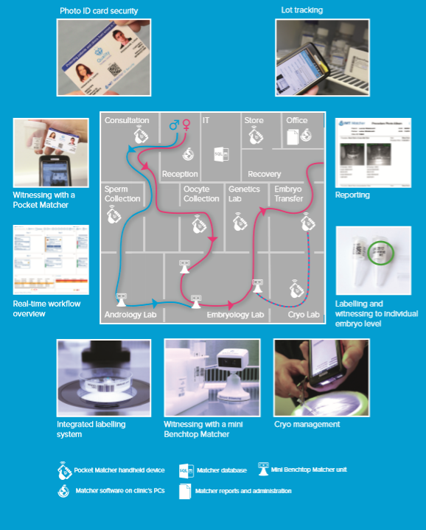

Appendix 6: Summary of Process Maps containing specific Witness Steps [Amend]

- IVF with Fresh Oocyte and Fresh Sperm Witnessing Pathway
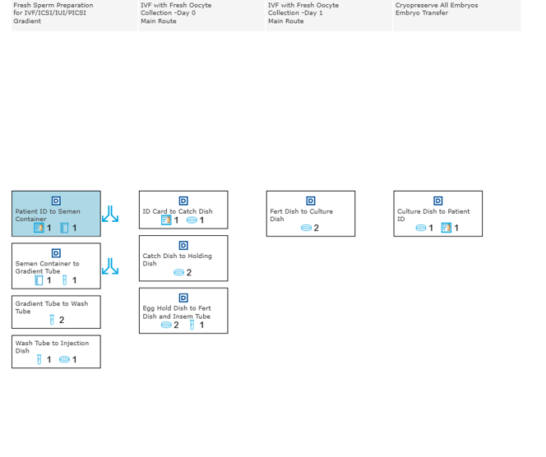
  - IVF with Fresh Oocyte and Fresh Sperm – alternative routes

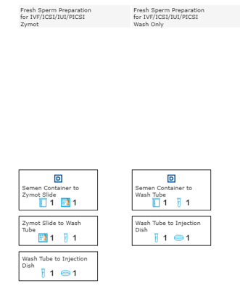

- IVF with Fresh Oocyte and Thawed Sperm Witnessing Pathway

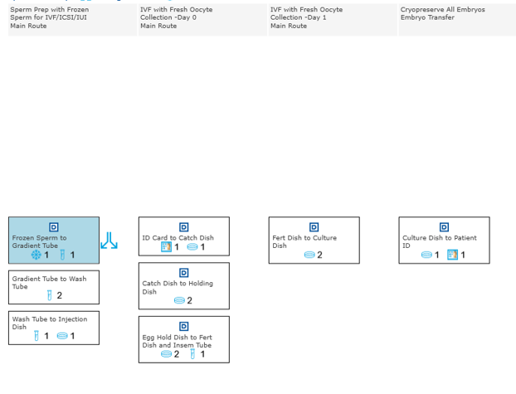
  - IVF with Fresh Oocyte and Thawed Sperm -alternative routes

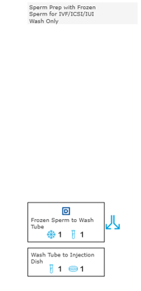

3. ICSI with Fresh Oocytes and Fresh Sperm Witnessing Pathway
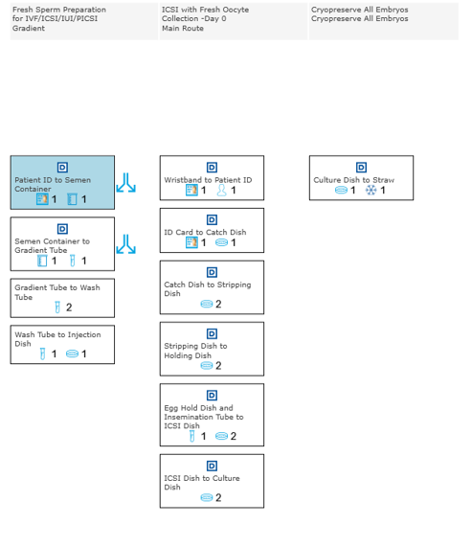
3.1. ICSI with Fresh Oocytes and Fresh Sperm-alternative routes

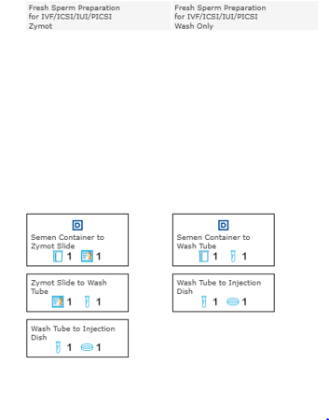

- ICSI with Fresh Oocytes and Thawed Sperm Witnessing Pathway
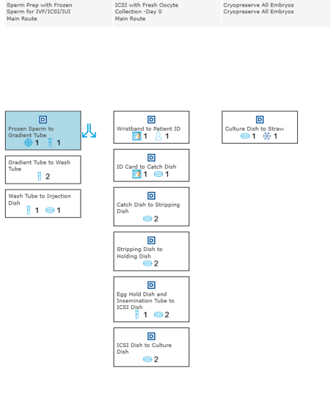
4.1 ICSI with Fresh Oocytes and Thawed Sperm – alternative routes
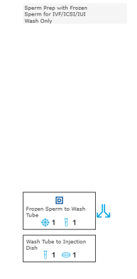

- ICSI with Thawed Oocytes and Fresh Sperm Witnessing Pathway
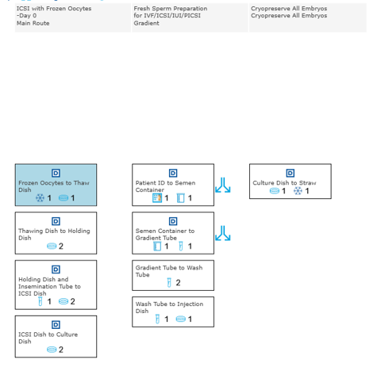
5.1 ICSI with Thawed Oocytes and Fresh Sperm – alternative routes
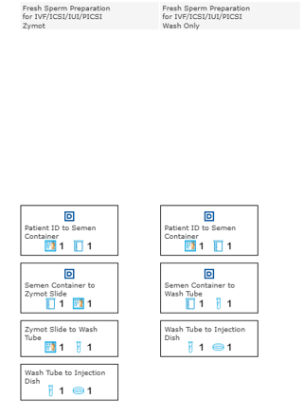

- ICSI with Thawed Oocytes and Thawed Sperm Witnessing Pathway
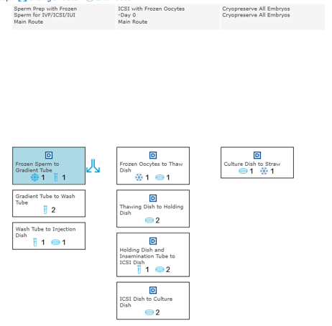
  - ICSI with Thawed Oocytes and Thawed Sperm
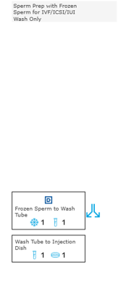

- Frozen Embryo Transfer Witnessing Pathway

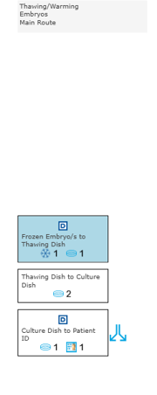
7.1 Frozen Embryo Transfer – alternative routes
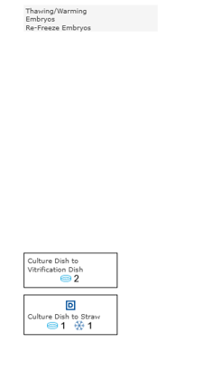

- IUI/Donor Insemination with Fresh Sperm Witnessing Pathway

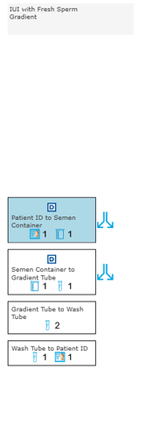
8.1 IUI/Donor Insemination with Fresh Sperm Witnessing Pathway

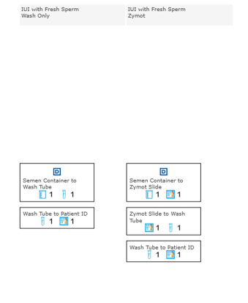

- IUI/Donor Insemination with Frozen Sperm Witnessing Pathway
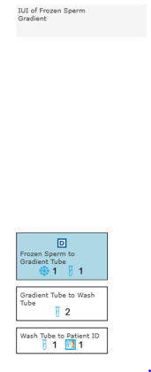

- Oocyte Cryopreservation Witnessing Pathway
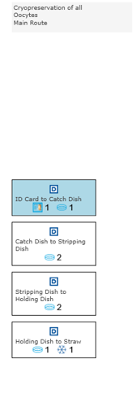

- Sperm Cryopreservation Witnessing Pathway
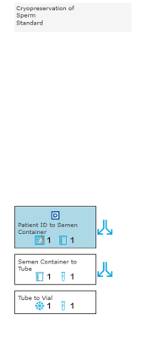

  - Sperm Cryopreservation alternative routes
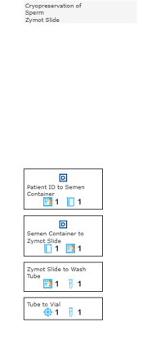

- Blood Testing Witnessing Pathway

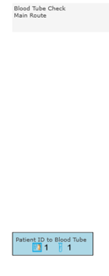

- Mock Cycle Witnessing – Thaw, Biopsy and Re-Freeze Pathway
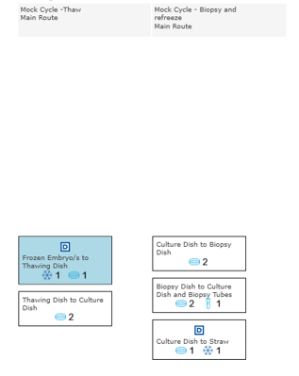

- ICSI with Embryo Transfer Witnessing Pathway

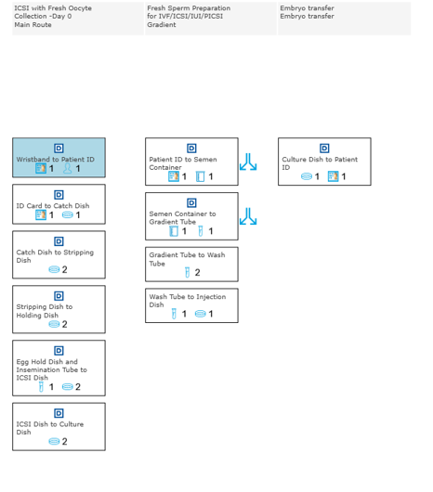
14.1 ICSI with Fresh Embryo Transfer – alternative routes
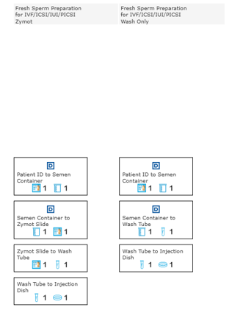

- IVF with Embryo Transfer Witnessing Pathway
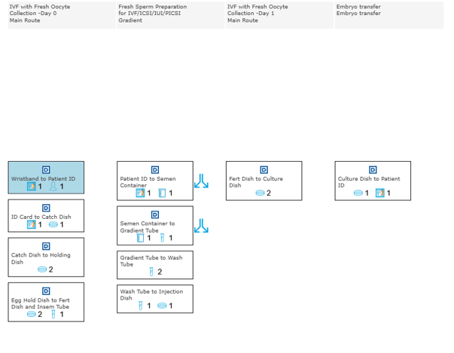
  - IVF with Embryo Transfer – alternative routes

