Matcher v5.6.0 Pocket Matcher mount guide

This guide provides users with instructions of how to effectively set up and use the Pocket Matcher mount.

The Pocket Matcher Mount securely holds the Pocket Matcher device in a fixed position to allow hands-free scanning of barcodes.

Guide contents:

- Installing the Pocket Matcher mount

- Inserting the Pocket Matcher into the mount

- Removing the Pocket Matcher from the mount

- Witnessing with the Pocket Matcher mount

- Cleaning the Pocket Matcher mount

- Charging the Pocket Matcher mount

- Installing the Pocket Matcher mount
Place the Pocket Matcher mount into a convenient location. The proposed ideal location within an IVF lab workstation is next to the microscope, or anywhere where the functionality of the Pocket Matcher can conveniently be utilised. Please see an example below:

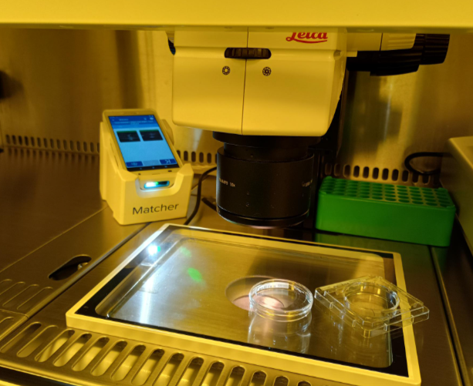

- Inserting the Pocket Matcher into the mount
Hold the Pocket Matcher upside down, and gently slide it downwards into the front grips of the mount device (1) . Then press down gently on the top of the device to ‘lock’ it into place (2):

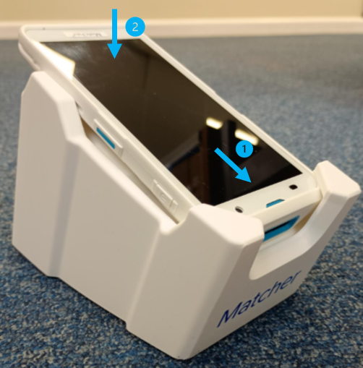

Please only insert the Pocket Matcher into the mount when the surrounding area is clear of patient material.

- Removing the Pocket Matcher from the mount
Removal is the opposite of insertion, and should be possible with a single hand. Gently lift the top of the Pocket Matcher so the upper half of the device is released from the side grips (1). Then slide the device upwards and out of the mount.

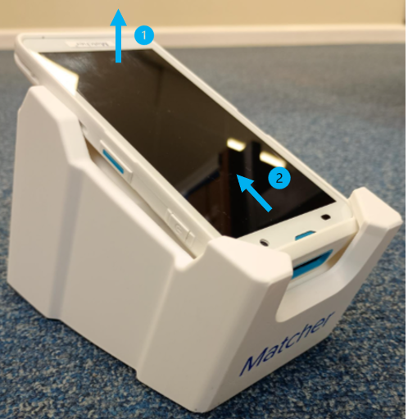

Please only remove the Pocket Matcher from the mount when the surrounding area is clear of patient material

- Witnessing with the Pocket Matcher mount
Place the Pocket Matcher mount into a convenient location.

The device should be oriented so that the user can easily reach and press the touchscreen. Users should aim to scan barcodes between 7-9cm away from the device. A green ‘aiming’ spot is designed to help users gauge the correct distance for scanning.

When the Pocket Matcher hands-free mode is in use, slowly move the device towards the green spot and the user should hear a beep which registers the barcode scan.

The user should then view the captured photograph to ensure it is clear and the printed barcode information is legible before proceeding with the next scan.

- Cleaning the Pocket Matcher mount
The Pocket Matcher mount can be operated with surgical gloves to promote hygienic use and infection control.

Standard use disinfectants such as the Oosafe range of products, chlorohexidine or 70% IPA are acceptable to use.

Because the Pocket Matcher mount will be handled frequently, it is recommended that it is wiped clean at least daily, but preferably after each use by an individual.

- Charging the Pocket Matcher
The Pocket Matcher can be charged in a couple of different ways.

The user can either remove the Pocket Matcher from the mount at the end of each day and place it into a charging dock to charge overnight. This option will preserve the life of the device battery:

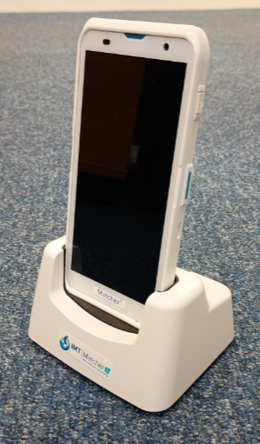

Alternatively, users can leave the Pocket Matcher permanently in the mount and attach a charging cable to the top of the device. Please be aware that leaving the device with the charging constantly attached may reduce the lifespan of the battery compared with other charging options:

